| **Date started** | **Date completed** |
| --- | --- |
| **17th December, 2022** | **6th January,2023** |

|  |
| --- |
| **Group Members Name & Roll Number** |
| 1. **ABUZAR F21BB133** |
| 1. **HANZALA RAMZAN F21BB106** |
| 1. **DANISH SHAKEEL F21BB122** |
| 1. **ADEEL MUSHTAQ F21BB140** |

|  |
| --- |
| **PROJECT INTRODUCTION** |
| The goal of the Project is to Build a Student Registration Portal. The Project is Divided into Five main Classes. First Three that are Student, Teacher, and Course are the Necessities of the other Two Classes that are Course Registration, for which Teacher and Course Classes are Mandatory as in this Class we will be Using Arrays of These Classes, and Student Registration, for which Student and Course Registration Classes are Mandatory. This Project will give a Complete Understanding about the Student Registration System of an Educational Institute. |

**Analysis**

**Try and create 3 or more key success criteria for your program.**

**Success Criteria:**

1. Project is Designed in such a way that there must be objects created in first three basic Classes to further Continue.
2. Project is able to Control Arrays, and it will take Array Index as Starting from 1 to Onward.
3. Project is Designed in such a way that getter setters are being Used for All Private Members of the Class.

|  |
| --- |
| ***INSTRUCTIONS*** |

* *You may like to create a flowchart which will show broadly how your program will work. If so, include your flow chart in this section.*
* *You must create pseudocode for a part of your program (minimum of fifteen lines). If possible, try to create all your programs in pseudocode.*
* The Project should be working on the computer with an executable exe and compile able code.
* The same project code should be submitted in paper format also. Without the paper format submission, no marks will be assigned.
* The code should have meaningful comments. Not commented will result in deductions.
* The variable names should be meaningful. Otherwise, it will result in deductions.
* The project needs to be completed with-in 3-week time once assigned.
* This project will be submitted in the proper project format as discussed in the class.
* The compile.sh bash file in the main folder for compiling is must part.
* Use of relative directory structure is a must part.
* Creation of header files with every c file is a must part.
* A util-header. h file will be created to hold all the header files and only this header file will be used outside.

|  |
| --- |
| ***INSTRUCTIONS CONT.*** |

* When submitting the project in the paper format please mention the path of the file from the main folder at the very top as a heading. THIS IS VERY IMPORTANT THAT YOU DO.
* Further Instructions are in documents provided to you.

**FLOW DIAGRAM:**

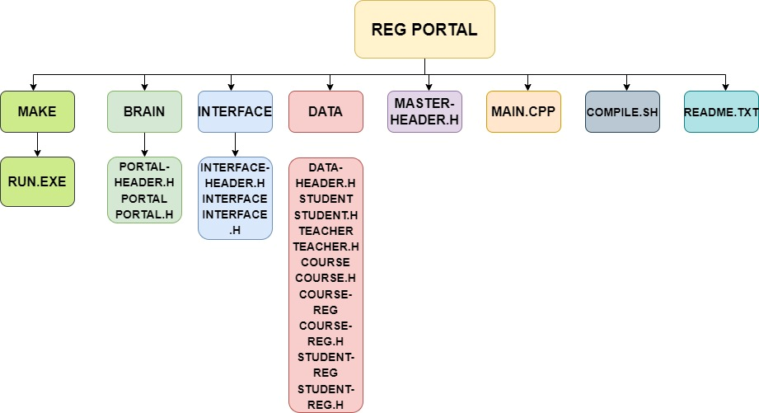

FLOW OF PROGRAM:

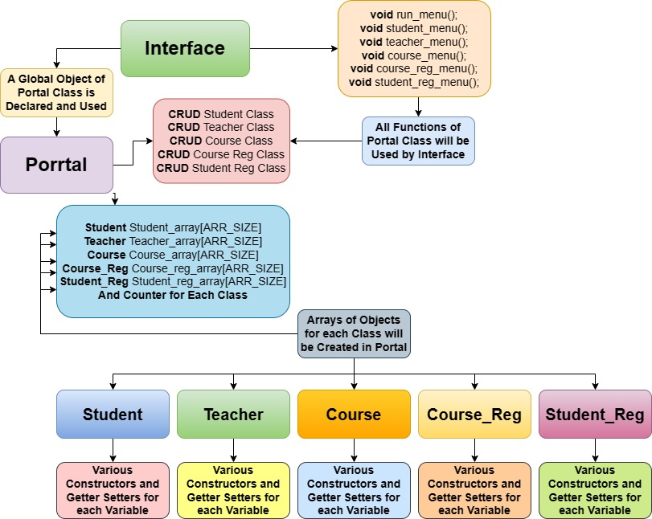

**Development**

* ***Copy and paste your code into this section***
* ***Remember to try and add comments to your code to make it more readable!***

**Pseudo code:**

1. Program will start with Run-Menu Function call, which is part of Interface, and Main-Menu will be Displayed on the Screen.
2. Menu will have six options that are 1 for Student Management, 2 for Teacher Management, 3 for Course Management, 4 for Course Registration, 5 for Student Registration, and -1 for Exit.
3. By Pressing 1 Student-Menu Function will be called, and Menu will be Displayed. It will Have Eight Options that are 1 for Creating List of Students, 2 to Add a student, 3 to Update Student, 4 to Print List of Existing Students, 5 to Delete Student, 6 to Get a Specific Student from the List, 0 for Returning Back to Main Menu, and -1 to Exit the Program.
4. By Pressing 1 i-f-create-student-list Function will be Called, in which Loop will work until it reaches to Number of Students to Add and Students will be Added to List by Using Portal Add Student Function.
5. By Pressing 2 i-f-add-student Function will be Called, in which Student will be Added to List by Using Portal Add Student Function.
6. By Pressing 3 i-f-update -student Function will be Called, in which A student will be Updated in the List by Using Portal’s Update Student.
7. By Pressing 4 i-f-print-student-list Function will be Called, in which Loop will Work until it reaches to the Count of Students Objects Present in the Student-Array.
8. By Pressing 5 i-f-delete-student Function will be Called, in which Student Available at Specific index will be Replaced by an Empty Object which have Zero Values for Different Members of that Class.
9. By Pressing 6 i-f-get-student Function will be Called, in which a Loop will Work until it Reaches to the Index that User want to Get from Specific Position, when Loop Reaches to that Index, the Data of the Student Present at that Position will be Displayed.
10. By Pressing 0 User will Move Back to Main Menu.
11. By Pressing -1 Program will Exit.
12. The Step from 3 to 11 are Same for each Class.
13. But there is a little bit change in Student Reg and Course Reg Classes as in these we pass indexes as the inputs.
14. In these Classes before taking input required Class’s available Objects list will be Printed.
15. And after taking the Input Student/Teacher details and Course’s Name will be Printed.

**Testing**

* ***Show you have completed the tests you thought of***
* ***Identify if you needed to update your program***
* ***Include the screenshots of the tests***

**My tests:**

|  |  |  |
| --- | --- | --- |
| Test | What am I assessing? | Expected result |
| 1 | Array Index Starting from 1 | Test Case Passed |
| 2 | First 3 Classes Have Objects to Continue for Other Two Classes | Test Case Passed |
| 3 | Input Validations | Test Case Passed |
| 4 | If No Objects are already created Error Massage | Test Case Passed |
| 5 | If user ENTER without input error massage | Test Case Passed |

|  |
| --- |
| **My Test Screenshots** |

**Evaluation**

* **Evaluate how successful your program was. You should like your evaluation to your testing results.**
* **You should reflect on any new skills you have developed**
* **All 3 members of your group must answer the following questions Separately.**

**This section should be 200-500 words.**

**How successful was my program?**

The Project is Completing 95% of its requirements. Project is to Build a Student Registration Portal. The Project is Divided into Five main Classes. First Three that are Student, Teacher, and Course are the Necessities of the other Two Classes that are Course Registration, for which Teacher and Course Classes are Mandatory as in this Class we will be Using Arrays of These Classes, and Student Registration, for which Student and Course Registration Classes are Mandatory. This Project will give a Complete Understanding about the Student Registration System of an Educational Institute.

**What new skills have I developed?**

This Project was very useful for us to understand different concepts with sincerity. This Project was a good approach for beginners to have great understanding of different core concepts of Object-Oriented-Programming in detail. We have gained much knowledge due to this Project. This was very helpful to us as Beginner.